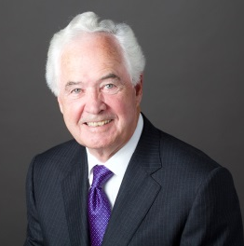
James B. Nicholson
Chairman
PVS Chemicals, Inc.
Detroit, Michigan 48213
Business Phone: 313.921.1200
jnicholson@pvschemicals.com

James B. Nicholson is chairman of Detroit based PVS Chemicals, Inc. PVS manufactures, distributes and markets chemicals used in diverse industries around the world.
Nicholson is widely known for his civic and charitable activities. He has been honored by numerous charitable organizations and was named Michiganian of the Year in 2004. He currently serves as chairman of the board of the Community Foundation for Southeastern Michigan. He is a past Chairman of the Boards of Business Leaders for Michigan, the Michigan Nature Conservancy, the Futures Foundation, and the YMCA of Metropolitan Detroit. He is a current member and past chairman of the boards of the Detroit Symphony Orchestra and Detroit Public Television. He also serves on the boards of the Michigan Colleges Foundation and the Detroit Economic Club.
In 2006, President George W. Bush appointed Nicholson to the National Infrastructure Advisory Council where he served until 2015. In 2011, he was appointed by Michigan Governor Rick Snyder to the Investment Advisory Committee where he served until 2021, chairing from 2015-2020. He has also chaired the Michigan Strategic Fund, the Detroit region’s Tourism Economic Development Council and the Wayne County Airport Authority Board. Mr. Nicholson is past chairman of the board of the Amerisure Companies and served as Lead Independent Director on the board of DTE Energy.
Mr. Nicholson earned a BA in Economics from Stanford University, an MBA from the University of Chicago, and a Master of Science Degree in economics from the London School of Economics.

